1. Deploy on Kovan – change MetaMask to Kovan Test Network

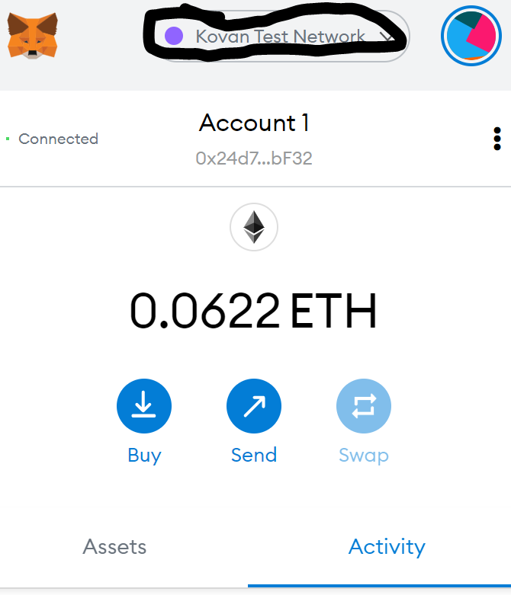

1. Go to the PupperCoinSaleDeployer contract and enter the Deploy fields, hit transact and confirm in MetaMask (Address should be the same as above)

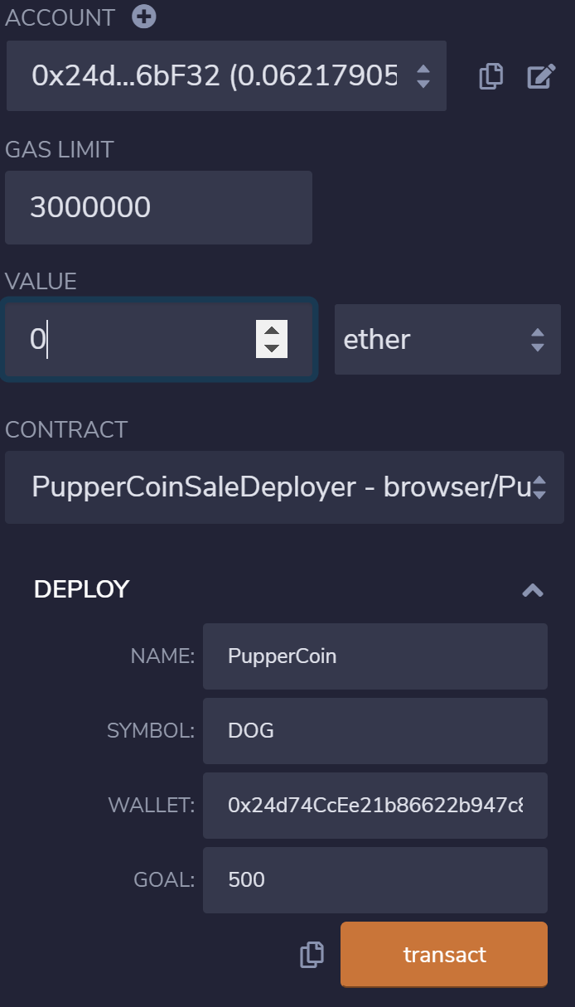

1. Potentially get additional Kovan TestNetwork ether (kovan.faucet.enjin.io)

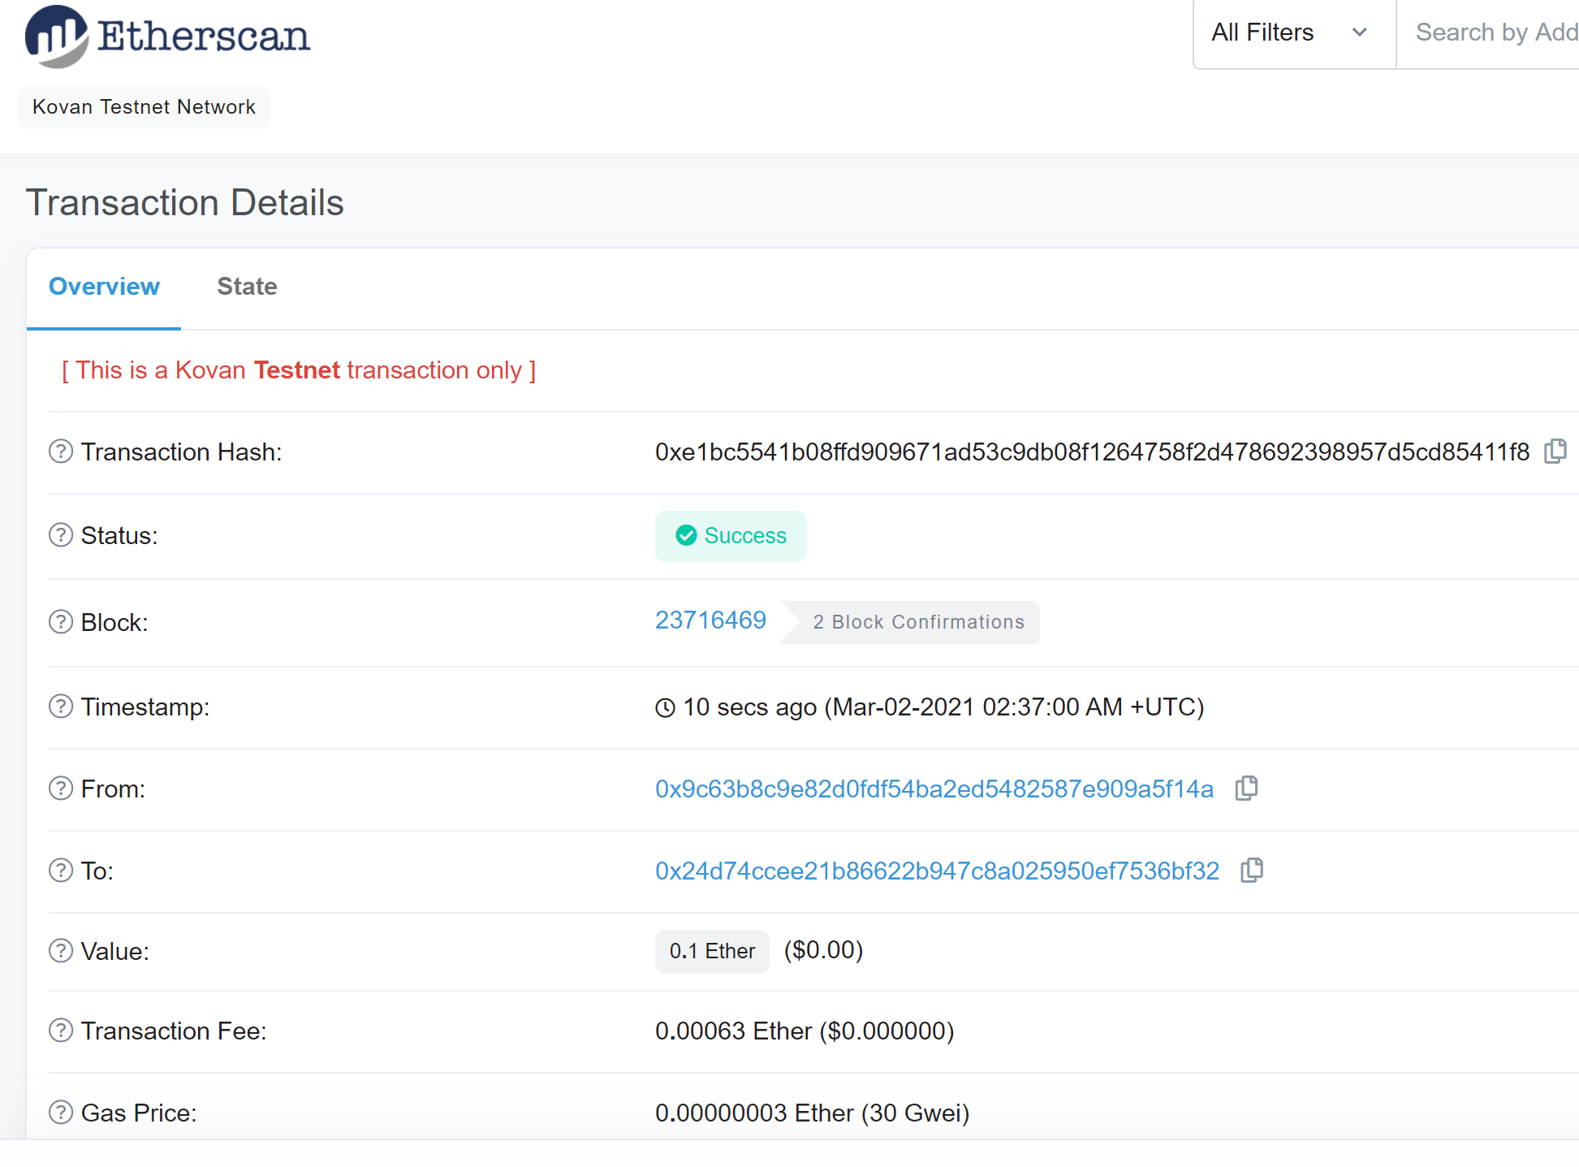

1. Confirm deployment on Kovan TestNetwork worked by checking addresses:

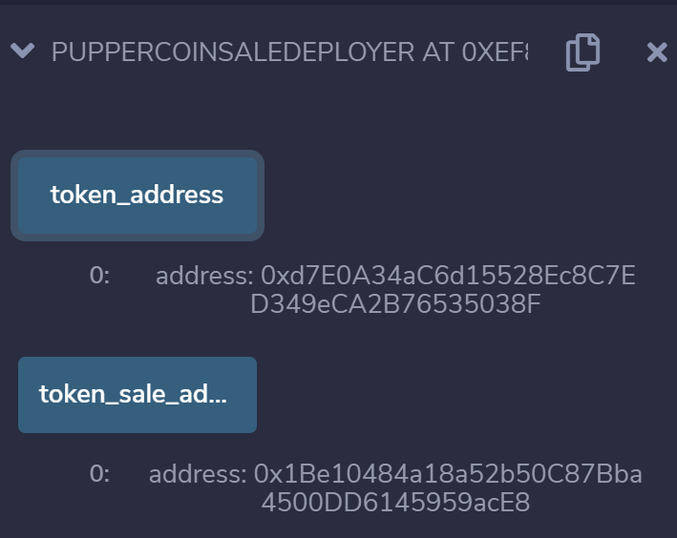

1. Unable to prove that it worked…

